Name-Shreya Panda
PRN – 25070122181
Class- B3 (25-29)
Subject: Programming with Java
ASSIGNMENT No :2
TITLE :Develop a Java application demonstrating the use of default, parameterized, and copy constructors for object initialization and data management.
Problem Statement
Develop a Java application demonstrating the use of default, parameterized, and copy constructors for object initialization and data management.
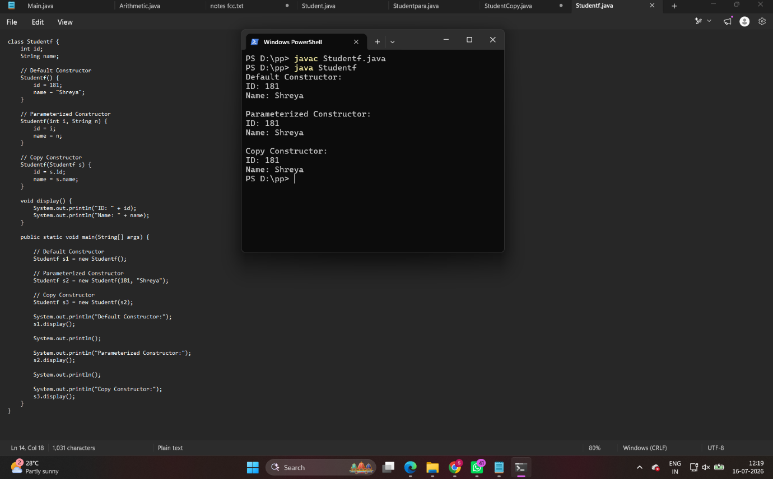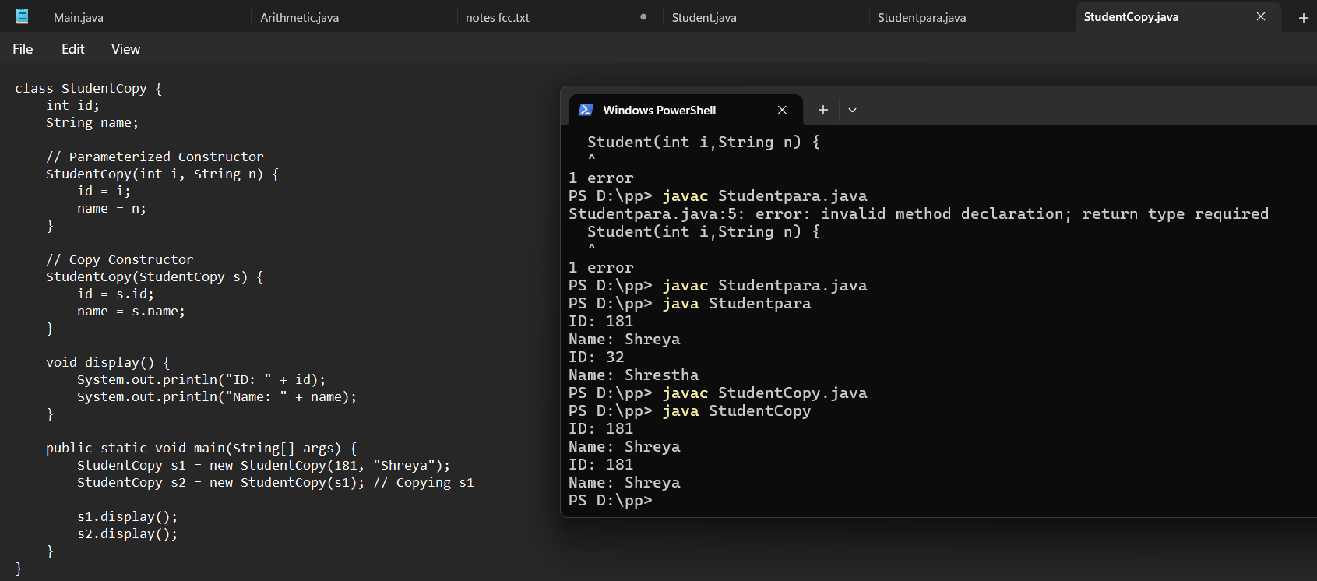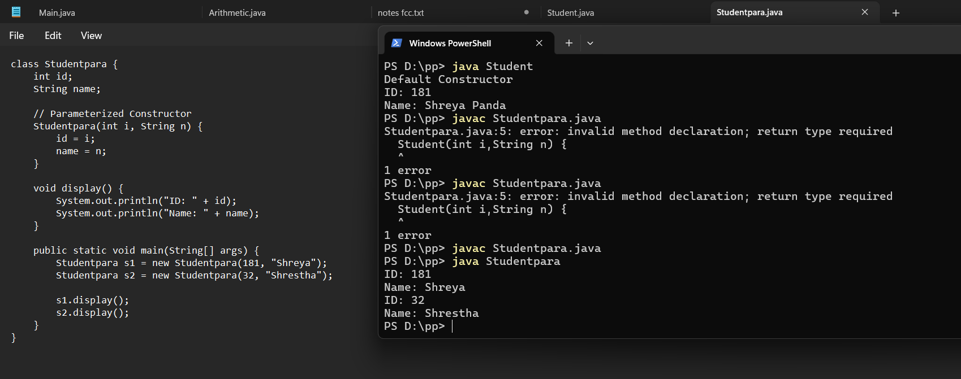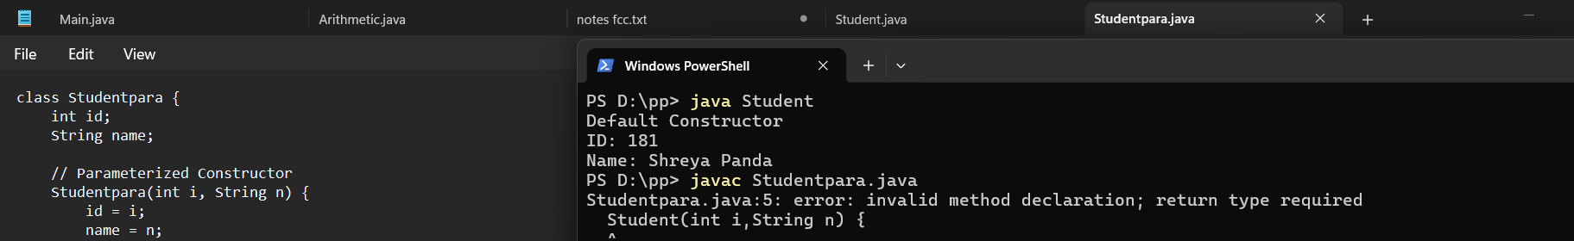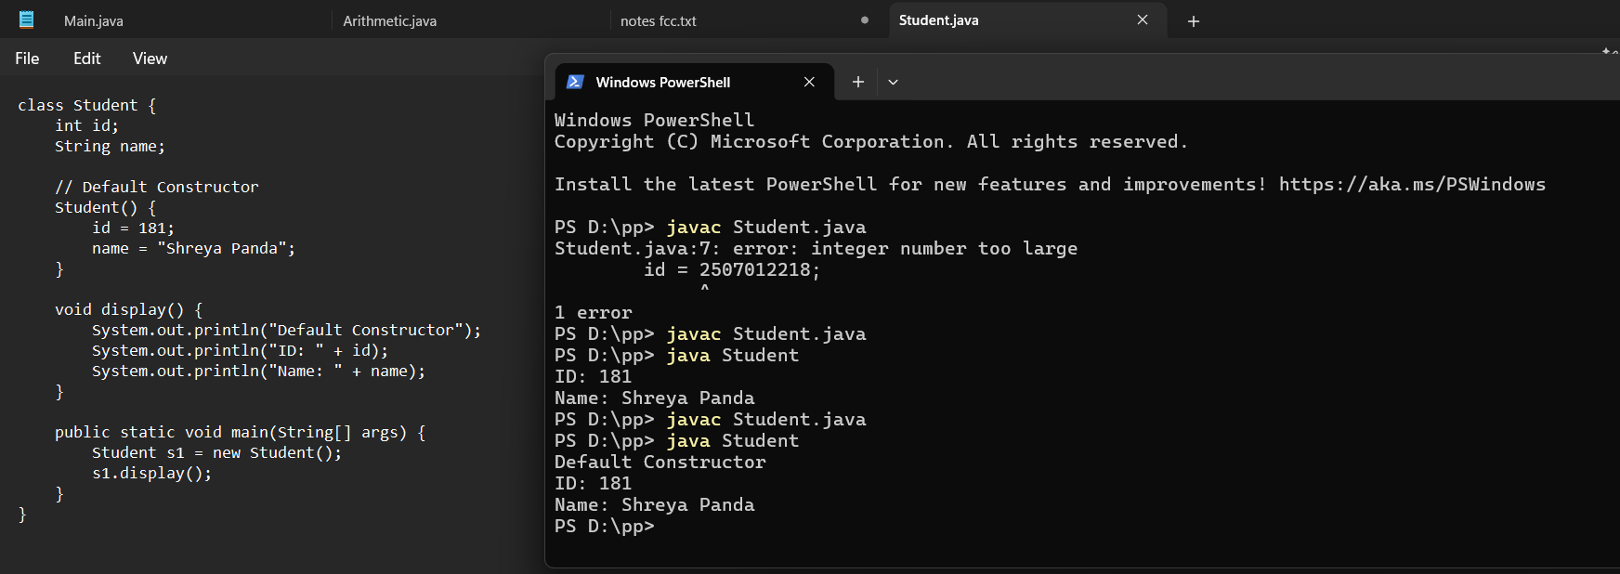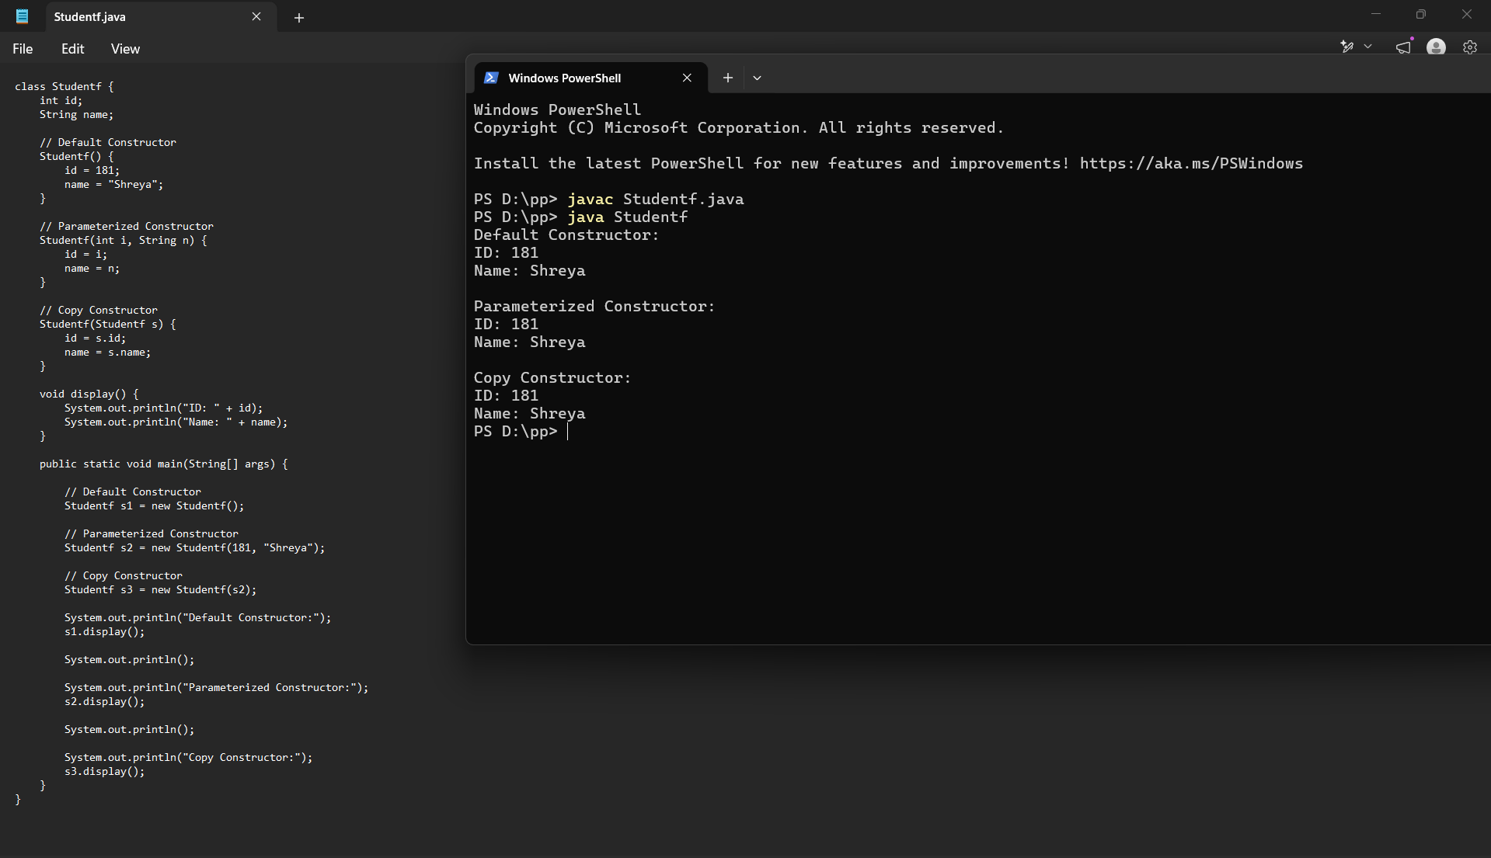
Conclusion
This Java application successfully demonstrates the use of default, parameterized, and copy constructors for object initialization and data management. The default constructor initializes objects with predefined values, the parameterized constructor allows user-defined initialization, and the copy constructor creates duplicate objects with the same data. Through the Student class and Mobile Phone Inventory System examples, the assignment highlights how constructors improve code organization, readability, and reusability while supporting the principles of object-oriented programming. Overall, the implementation provides a clear understanding of constructor overloading and object creation in Java.

